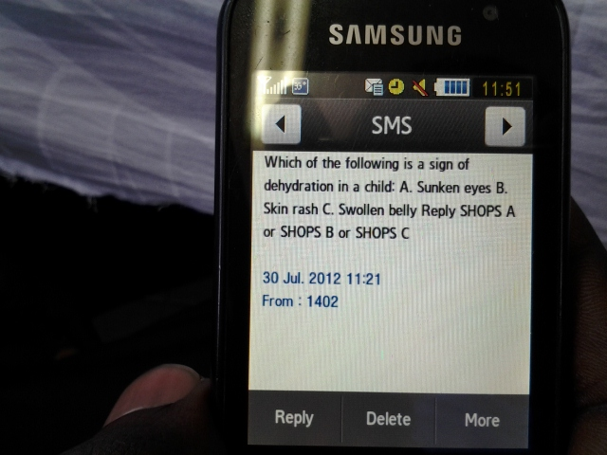

**HEALTH WORKER TEXT MESSAGE DEVELOPMENT EXERCISE**

**Background**: Effective behavior change communication addresses the underlying cognitive, emotional, social, and environment factors that influence health worker practices. Text messages complement other channels to reinforce training (face-to-face training, skills practice, supervision, paper job aids). Messages should take into account limitations (160 characters not suitable for complex instructions) and strengths (repeatable, personal, private).

**Learning Objectives**: Based on a process used in SHOPS project Mobiles for Quality Improvement (collaboration with Abt, Jhpiego, Marie Stopes International), this exercise is intended to highlight factors to ensure relevance and impact in developing text tips and reminders. At the end of the exercise participants will have a framework for organizing group input to message development within their local context.

Exercise is done in groups to take advantage of variety of perspectives, insights and experiences. Point of the exercise is to experience the process used, not to develop end product.

After small group breakout sessions, participants will come together to share their experiences with the larger group – Was this process useful? What made it challenging? What questions would you add to the matrix?

**Small Group Training Exercise for Text Message Development**

**(30 minutes)**

1. **STEP ONE**

Choose one content area from three illustrative case descriptions attached: family planning counseling, promoting ART adherence for HIV/AIDS workers, or treating uncomplicated diarrhea in children. Or come up with your own.

1. **STEP TWO**

Select one indicator for your topic area. You can select one of those provided or come up with your own.

**3. STEP THREE**

Fill the attached matrix. A sample completed matrix is attached as a guide. Group should brainstorm about range of factors that address the questions asked.

**4. STEP FOUR**

Develop 2-3 text messages based upon insights developed from matrix exercise. Messages should be tied to the indicator you are measuring, to remind, reinforce and encourage CHW to take the action described. Remember there is a 160 character limit.

**Reconvene in large group to share insights and challenges with the process.**

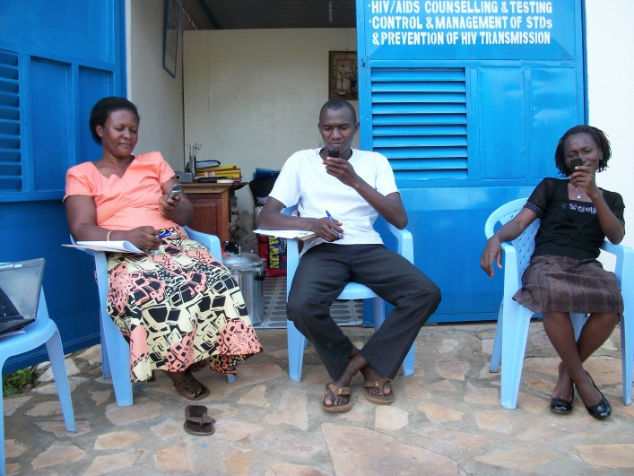

**CHOOSE ONE TOPIC AREA with ONE INDICATOR**

**(OR MAKE UP YOUR OWN)**

1. HIV/AIDS topic: Text messages to improve CHW counseling on ART adherence

Consistent ART adherence is a big challenge in effectively managing the disease. Clients may not understand the importance of never missing their daily pills, they may experience side effects warranting adjustments to their treatment, they may have transportation or other challenges getting their meds refilled when they run out. CHWs can play an important role educating, motivating and facilitating improved adherence. Possible indicators:

* CHWs should always ask their clients open-ended question about problems they have taking pill every day.
* CHW should identify what family and social support is available to the client, and link the client to peers and social institutions.

2. Pediatric diarrhea topic: Text messages to improve CHW dispensing/recommendation of ORS and zinc.

WHO recommends ORS and zinc for treatment of uncomplicated diarrhea, but many health workers recommend Flagyl or antibiotics. Antibiotics do not protect against future episodes or treat dehydration, which can be fatal. Clients may resist using unfamiliar products, or find their children don’t like the taste of zinc and ORS. CHWs can serve an important role in educating caregivers on the importance of recommended treatment. Possible indicators:

* Providers always counsel caregivers to give complete 10-day regimen of zinc to get full benefits and protect against future episodes of diarrhea
* Providers never recommend antibiotics for uncomplicated diarrhea symptoms (where no blood in the stool)

3. Family planning topic: Text messages to strengthen CHW ability to present all contraception options accurately and neutrally.

The concept of informed voluntary choice of contraceptive methods is fundamental to a provider’s role in counseling women about timing and spacing of pregnancies. Women have many methods to choose from depending upon their stated and unstated needs, age, health, preferences, economic means, and family support. Women may lack knowledge about their options, have myths or misinformation about specific methods, and defer to family members in evaluating options. Possible indicators:

* Providers ask open-ended questions to learn about client needs, preferences, and concerns.
* Providers provide information about all available methods of contraception to facilitate informed choice.

**Matrix to guide text message development**

|  |  |  |  |
| --- | --- | --- | --- |
| |  |  | | --- | --- | |  |  | | **Indicator:** |
| **Why is this indicator important?** |  |
| |  |  |  |  | | --- | --- | --- | --- | | **Why is this indicator not regularly met?** |  |  |  | |  |
| |  |  |  |  | | --- | --- | --- | --- | | **Why should the provider care about this indicator?** |  |  |  | |  |
| |  |  |  | | --- | --- | --- | | **Why should the client care about this indicator?** |  |  | |  |
| |  | | --- | | **What specific information is provided about this indicator**  **in training manuals, job aids?** | |  |

**M4QI FRAMEWORK FOR MESSAGE DEVELOPMENT**

**Sample analyses from Marie Stopes’s infection prevention training**

|  |  |  |  |  |  |  |
| --- | --- | --- | --- | --- | --- | --- |
| |  |  | | --- | --- | |  |  | | |  |  | | --- | --- | | **Indicator #1**  **Team members wash their hands BEFORE and AFTER examining or providing a service for every client.** |  | | **Indicator #2**  **Sharps are placed in a sharps container immediately following use.** |
| **Why is this indicator important?** | * Reduces spread of infection | * Pricking is number one source of blood-borne infections |
| |  |  |  |  | | --- | --- | --- | --- | | **Why is this indicator not regularly met?** |  |  |  | | * Too busy * Too many clients, tend to trail off hand washing over time * Need to start on time, end on time * Afraid to turn away clients and tell them when you‘ll be returning (possibly on the weekend or maybe not until next week or month) * People get tired and don‘t find it important | * Sharps container gets too full, not emptied regularly * Sometimes wrong type of container is used (not stiff enough material). If container is there, rare that won‘t be used. * There are three kinds of sharps; needle with syringe is generally placed right away in container. The other two sharps are more the problem (surgical razor, needle for stitching). |
| |  |  |  |  | | --- | --- | --- | --- | | **Why should the provider care about this indicator?** |  |  |  | | * Habit will keep providers healthier * Prevents transmission of infection from client to provider * Prevents infections of family members * Risk of injury and transmission of infections | * Provider is at risk of hepatitis, HIV * Infection will result in Incurring more expenses |
| |  |  |  | | --- | --- | --- | | **Why should the client care about this indicator?** |  |  | | * Reassures them that MSU utilizes safe practices * Prevents infection from client to client | |  |  | | --- | --- | | * Patient at risk of accidental puncture and risk of acquiring infections |  | |
| |  | | --- | | **What specific information is provided about this indicator in training manuals, job aids?** | | * How often, how long, when alcohol rub is advised | * How to label containers, how to dispose of containers, where containers should be located |